DataFrame Transformations and Actions
Column Functions
- col()
- lit()
- when()
- concat()
Data Cleaning and Data Wrangling in PySpark
Data Cleaning & Data Wrangling are essential steps in any PySpark data-processing pipeline. Real-world data is rarely perfect. It may contain missing values, duplicate record, inconsistent text, invalid formats, unnecessary whitespaces, inconsistent capitalization, or incorrectly formatted values.
In PySpark, these problems are typically handled using DataFrame Transformations & functions from pyspark.sql.functions.
Data Cleaning
Data Cleaning is the process of identifying & correcting or removing inaccurate, incomplete, inconsistent, or irrelevant data.
Typical data-cleaning activities include:
- Handling missing values.
- Removing duplicate records.
- Correcting invalid or inconsistent formats.
- Standardizing strings.
- Correcting inconsistent capitalization.
- Removing unwanted characters.
- Validating data against business rules.
- Converting columns to appropriate data types.

e.g.
Employee dataset
emp_id | name | department | salary
101 | ` John ` | IT | 60000
102 | MARY | hr | 55000
103 | David | null | 70000
103 | David | null | 72000
104 | Lisa | Finance | null

Data cleaning attempts to transform this into a reliable dataset.

Data Wrangling
Data Wrangling is the broader process of transforming raw data into a structured & usable form for analysis, reporting, machine learning, or downstream processing.
It generally involves:
- Understanding the raw data.
- Inspecting the schema & values.
- Cleaning incorrect data.
- Handling missing values.
- Removing the duplicates.
- Standardizing the formats.
- Transforming the columns.
- Combining datasets.
- Validating the resulting dataset.

Data cleaning improves the data quality, while Data Wrangling prepares the data for use.

Data Quality Challenges
Data Quality refers to how accurate, complete, consistent, valid, & reliable the data is.
The common challenges are:
- Missing Values
- Duplicates
- Invalid Formats
Techniques
- Null Handling
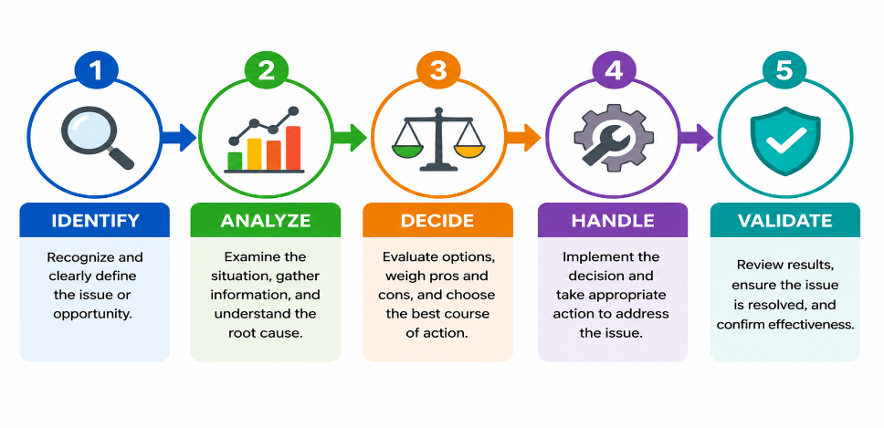
PySpark provides:
- Identify null values
Before deciding what to do, you need to understand where nulls exist.
Typical questions include:
    - Which columns contain nulls?
    - How many nulls are present?
    - What percentage of records contain nulls?
    - Are nulls expected or unexpected?
    - Can the missing value be derived?
    - Should the record be removed?
- Remove rows containing nulls using dropna().
- Duplicate Removal
Duplicates can lead to:
  - Incorrect record counts
  - Inflated totals
  - Incorrect averages
  - Duplicate payments
  - Incorrect reporting
  - Incorrect machine-learning training data
  - Increased storage requirements
PySpark provides distinct() & dropDuplicates() operations for duplicate handling.
- String Manipulation
  - trim()
  - lower()
  - upper()
  - regexp_replace()

List of Important PySpark functions
Function | Purpose | Typical use
dropna() | Remove rows containing nulls | Remove incomplete records
fillna() | Replace null values | Replace missing values
distinct() | Remove completely identical rows | Remove exact duplicates
dropDuplicates() | Remove duplicates based on selected columns | Business-key deduplication
trim() | Remove surrounding whitespace | Clean names/categories
lower() | Convert text to lowercase | Standardize text
upper() | Convert text to uppercase | Standardize codes/categories
regexp_replace() | Replace text based on regex | Remove/replace patterns

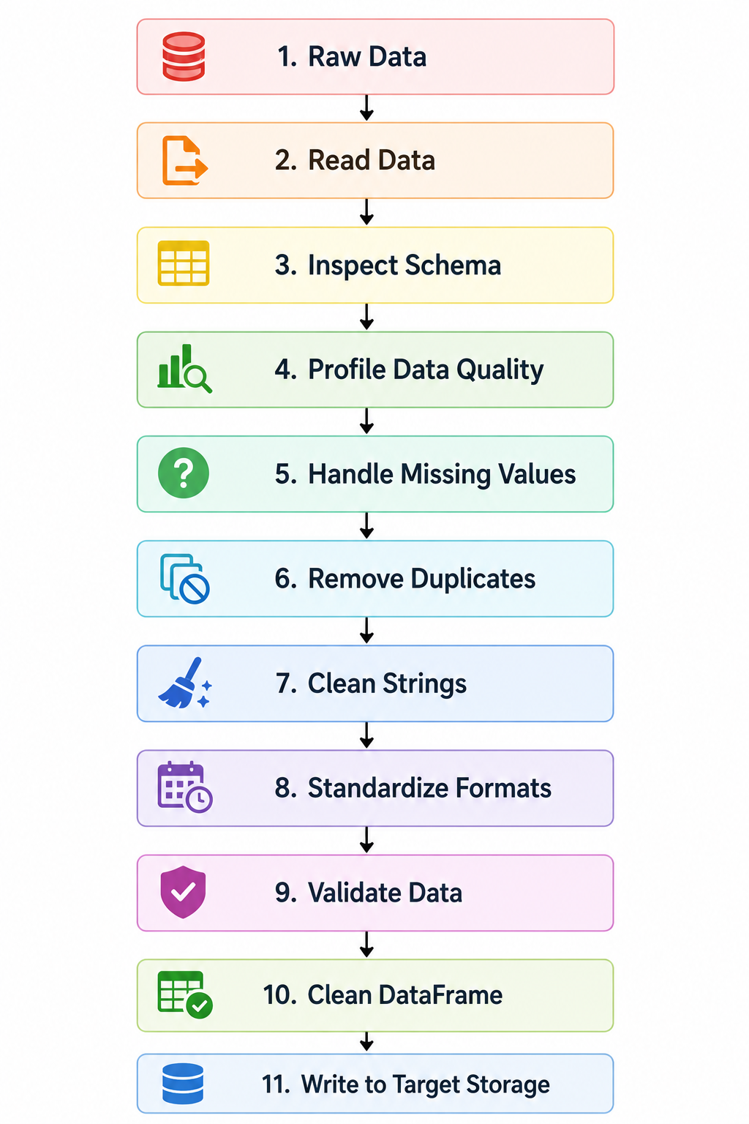

Assignment
Customer data cleansing project
Problem Statement: Customer Data Cleansing and Data Wrangling Project
Project Title
Customer Data Cleansing and Data Wrangling using PySpark

1. Business Scenario
A retail organization receives customer information from multiple sources such as:
- Online shopping applications
- Physical retail stores
- Customer registration systems
- Marketing platforms
- CRM applications
- Third-party data providers
Over time, customer data has become inconsistent and unreliable because the information is collected from different systems and entered by different users.
The organization wants to build a PySpark-based customer data cleansing pipeline that can identify and correct common data-quality problems before the data is used for analytics, reporting, marketing campaigns, and customer segmentation.
The raw customer dataset contains problems such as:
- Missing customer information
- Duplicate customer records
- Leading and trailing spaces
- Inconsistent capitalization
- Inconsistent department/category values
- Invalid email addresses
- Phone numbers containing spaces, hyphens, and other characters
- Inconsistent textual representations
Your task is to build a data cleaning and data wrangling process using PySpark DataFrame operations to convert the raw customer dataset into a clean and standardized customer dataset.

2. Business Objective
The primary objective is to create a trusted customer master dataset that can be consumed by downstream systems.
The cleaned dataset should:
- Contain unique customer records
- Have appropriate handling of missing values
- Have standardized customer names
- Have standardized customer categories
- Have normalized email addresses
- Have standardized phone numbers
- Identify invalid email formats
- Remove unnecessary whitespace
- Maintain consistent capitalization
- Remove or appropriately handle duplicate records
- Provide a reliable foundation for customer analytics

3. Input Dataset
The project will use a raw customer dataset with the following columns:
Column | Data Type | Description
customer_id | Integer | Unique customer identifier
customer_name | String | Customer's full name
customer_type | String | Type/category of customer
email | String | Customer email address
phone | String | Customer phone number
city | String | Customer city
state | String | Customer state
salary | Integer/Double | Customer income/value information

Sample raw data
customer_id | customer_name | customer_type | email | phone | city | state | salary
1001 | John Smith | regular | JOHN.SMITH@ABC.COM | 987-654-3210 | Vadodara | Gujarat | 65000
1002 | MARY JOHNSON | PREMIUM | mary.johnson@abc.com | 9876543211 | Mumbai | maharashtra | 85000
1003 | David Brown | Regular | DAVID.BROWN@ABC.COM | 987 654 3212 | Ahmedabad | GUJARAT | 72000
1003 | David Brown | Regular | DAVID.BROWN@ABC.COM | 987 654 3212 | Ahmedabad | GUJARAT | 72000
1004 | Lisa Wilson | NULL | lisa.wilson@abc.com | 987-654-3213 | Surat | Gujarat | NULL
1005 | NULL | regular | james@abc | 987-654-3214 | Vadodara | Gujarat | 62000
1006 | Robert Taylor | REGULAR | robert.taylor@abc.com | 9876543215 | Pune | Maharashtra | 65000
1007 | Susan Lee | premium | NULL | 987-654-3216 | Rajkot | Gujarat | 58000
1008 | Peter Adams | Premium | peter.adams@abc.com | NULL | Delhi | Delhi | 72000

4. Data Quality Challenges
The raw customer dataset contains the following problems.

Challenge 1 — Missing Values
Some customer records contain missing information.
For example:
- Missing customer_name
- Missing customer_type
- Missing email
- Missing phone
- Missing salary
The data-engineering team must determine how these missing values should be handled.
Requirements
Identify all columns containing null values and determine the number of missing values in each column.
The solution should distinguish between:
Mandatory fields
Examples:
- customer_id
- customer_name
A record without a customer ID may not be usable.
Optional fields
Examples:
- salary
- phone
A missing optional field may not necessarily require removal of the customer record.

5. Null Handling Requirements
Implement appropriate null-handling strategies.
The project should demonstrate both:
A. Null replacement
Use appropriate default values where business rules permit.
For example:
Column | Possible replacement
customer_type | UNKNOWN
email | NOT_AVAILABLE
phone | NOT_AVAILABLE
salary | Business-defined default

B. Null removal
Records with missing critical information should be removed where appropriate.
For example:
A customer record without customer_id should not be retained in the customer master dataset.
The project should clearly explain why a particular null-handling strategy was selected.

6. Challenge 2 — Duplicate Customers
The raw data may contain duplicate customer records.
For example:
customer_id | customer_name | email
1003 | David Brown | david.brown@abc.com
1003 | David Brown | david.brown@abc.com

The same customer has been loaded more than once.

Duplicate Removal Requirements
The solution should:
- Identify duplicate records.
- Determine the number of duplicate records.
- Identify the business key.
- Remove duplicate customer records.
- Validate that duplicate customers no longer exist.
Assume that:
customer_id is the unique business key for customers.
The project should demonstrate the difference between:
- Exact duplicate removal
- Duplicate removal based on customer_id
Use appropriate PySpark operations such as:
- distinct()
- dropDuplicates()

7. Challenge 3 — Invalid Formats
Customer information may not follow expected formatting rules.
Examples include:
Invalid email
james@abc
Expected format:
james@abc.com
Phone number inconsistency
The dataset might contain:
987-654-3210
9876543210
987 654 3210
All may represent the same phone number.
Customer type inconsistency
The dataset may contain:
regular
Regular
REGULAR
regular
These should be treated as the same logical value.

8. String Cleaning Requirements
The project must demonstrate the following PySpark string functions.

A. trim()
Use trim() to remove leading and trailing whitespace.
Apply it to appropriate columns such as:
- customer_name
- customer_type
- city
- state
- email
For example:
" John Smith "
should become:
"John Smith"
Similarly:
" Gujarat "
should become:
"Gujarat"

9. Standardize Text Using lower()
Email addresses should be standardized to lowercase.
For example:
JOHN.SMITH@ABC.COM
should become:
john.smith@abc.com
The solution should use lower() as part of the email-cleaning process.
A recommended conceptual sequence is:
Original Email
↓
trim()
↓
lower()
↓
Standardized Email

10. Standardize Text Using upper()
Customer category/type values should be standardized to uppercase.
For example:
Original | Standardized
regular | REGULAR
Regular | REGULAR
REGULAR | REGULAR
premium | PREMIUM
Premium | PREMIUM

The solution should use:
trim()
↓
upper()
to create consistent category values.

11. Clean Phone Numbers Using regexp_replace()
Phone numbers may contain:
- Spaces
- Hyphens
- Parentheses
- Other special characters
Examples:
987-654-3210
987 654 3210
(987) 654-3210
The project should use regexp_replace() to remove unwanted characters.
The expected standardized result is:
9876543210
Therefore, all valid phone numbers should ideally contain only numeric characters after cleansing.

12. Clean Multiple Spaces
Customer names may contain unnecessary spaces between words.
For example:
John Smith
should become:
John Smith
The project should demonstrate the use of regexp_replace() to identify multiple whitespace characters and replace them with a single space.

13. Email Validation
The project should identify invalid email addresses.
Examples:
Email | Status
john.smith@abc.com | VALID
mary.johnson@abc.com | VALID
james@abc | INVALID
peter@ | INVALID
@abc.com | INVALID
The solution should use a suitable regular-expression pattern with PySpark to classify emails as:
- VALID
- INVALID
The invalid records should not necessarily be deleted immediately.
Instead, they should first be identified so that the business can decide whether they should be corrected, quarantined, or removed.

14. Expected Data-Cleansing Process
The overall process should follow this sequence:
RAW CUSTOMER DATA
│
▼
Data Profiling
│
▼
Identify NULLs
│
▼
Handle NULLs
│
▼
Identify Duplicates
│
▼
Remove Duplicates
│
▼
Clean Customer Names
│
▼
Standardize Categories
│
▼
Clean Email Addresses
│
▼
Clean Phone Numbers
│
▼
Validate Email Format
│
▼
Data Validation
│
▼
CLEAN CUSTOMER DATA

15. Technical Requirements
The project must be implemented using PySpark DataFrame APIs.
The following functions should be demonstrated:
Null Handling
- isNull()
- dropna()
- fillna()
Duplicate Handling
- distinct()
- dropDuplicates()
String Manipulation
- trim()
- lower()
- upper()
- regexp_replace()
Data Validation
The project may additionally use:
- when()
- col()
- rlike()
- count()
- groupBy()
16. Expected Clean Dataset
After processing, the final dataset should have standardized information similar to:
customer_id | customer_name | customer_type | email | phone | city | state | salary
1001 | John Smith | REGULAR | john.smith@abc.com | 9876543210 | Vadodara | Gujarat | 65000
1002 | Mary Johnson | PREMIUM | mary.johnson@abc.com | 9876543211 | Mumbai | Maharashtra | 85000
1003 | David Brown | REGULAR | david.brown@abc.com | 9876543212 | Ahmedabad | Gujarat | 72000
1004 | Lisa Wilson | UNKNOWN | lisa.wilson@abc.com | 9876543213 | Surat | Gujarat | appropriate value
1005 | appropriate handling | REGULAR | INVALID/QUARANTINE | 9876543214 | Vadodara | Gujarat | 62000
1006 | Robert Taylor | REGULAR | robert.taylor@abc.com | 9876543215 | Pune | Maharashtra | 65000
1007 | Susan Lee | PREMIUM | NOT_AVAILABLE | 9876543216 | Rajkot | Gujarat | 58000
1008 | Peter Adams | PREMIUM | peter.adams@abc.com | NOT_AVAILABLE | Delhi | Delhi | 72000

The exact treatment of invalid and missing data should be justified by the student.

17. Data Quality Validation
After cleansing, the project should perform validation.
Validation 1 — Duplicate Customer IDs
There should be no duplicate customer_id values.
Duplicate customer IDs = 0
Validation 2 — Mandatory NULLs
There should be no null values in mandatory fields.
For example:
customer_id NULL count = 0
Validation 3 — Customer Type
Customer type should contain only accepted values, such as:
REGULAR
PREMIUM
UNKNOWN
Validation 4 — Phone Number
Clean phone numbers should contain only digits, where a valid phone number is present.
Validation 5 — Email
Email records should be classified as:
VALID
INVALID
Validation 6 — Whitespace
Customer names and categories should not contain unnecessary leading or trailing whitespace.

18. Business Acceptance Criteria
The project will be considered successful when:
- All missing values are identified.
- Missing values are handled according to defined business rules.
- Duplicate customers are identified and removed.
- customer_id is treated as the unique business key.
- Customer names are cleaned using trim().
- Customer names with multiple spaces are normalized using regexp_replace().
- Email addresses are trimmed and converted to lowercase.
- Customer types are trimmed and converted to uppercase.
- Phone numbers are standardized using regexp_replace().
- Invalid email addresses are identified.
- The final DataFrame contains standardized customer data.
- Data-quality checks are performed after cleansing.
- The solution demonstrates all required PySpark functions.
- The transformation process is clearly documented.

19. Student Tasks
The learner should complete the following tasks in sequence.
Task 1 — Create the Spark environment
Create a PySpark SparkSession.
Task 2 — Load the raw customer data
Create the raw customer DataFrame from the provided dataset.
Task 3 — Profile the data
Display:
- Schema
- Total record count
- Sample records
- Null counts
- Duplicate customer IDs
Task 4 — Handle missing values
Identify and appropriately handle missing values using:
- isNull()
- dropna()
- fillna()
Task 5 — Remove duplicates
Identify duplicate customers and remove them using:
- distinct()
- dropDuplicates()
Explain when each method should be used.
Task 6 — Clean customer names
Use:
- trim()
- regexp_replace()
to remove unnecessary whitespace.
Task 7 — Standardize customer types
Use:
- trim()
- upper()
to standardize customer categories.
Task 8 — Standardize email addresses
Use:
- trim()
- lower()
to normalize emails.
Task 9 — Validate email addresses
Use a regular expression to classify emails as:
- VALID
- INVALID
Task 10 — Standardize phone numbers
Use:
- regexp_replace()
to remove unnecessary characters.
Task 11 — Perform final validation
Verify:
- No unexpected duplicate customers
- No null customer IDs
- Standardized customer types
- Clean phone numbers
- Standardized emails
- Clean customer names

20. Final Deliverable
The final PySpark notebook should contain:
Customer Data Cleansing Project
│
├── 1. Project Introduction
├── 2. SparkSession Creation
├── 3. Load/Create Raw Customer Data
├── 4. Data Exploration
├── 5. Data Quality Assessment
│ ├── Missing Values
│ ├── Duplicates
│ └── Invalid Formats
│
├── 6. Null Handling
│ ├── isNull()
│ ├── dropna()
│ └── fillna()
│
├── 7. Duplicate Removal
│ ├── distinct()
│ └── dropDuplicates()
│
├── 8. String Manipulation
│ ├── trim()
│ ├── lower()
│ ├── upper()
│ └── regexp_replace()
│
├── 9. Email Validation
├── 10. Final Clean DataFrame
├── 11. Data Quality Validation
└── 12. Business Summary
Project Outcome
At the end of this exercise, the learner should be able to take a messy customer dataset and use PySpark to transform it into a clean, standardized, validated customer dataset suitable for downstream analytics and data-engineering workflows.
The project therefore provides a practical end-to-end demonstration of Data Cleaning, Data Wrangling, Data Quality Challenges, Null Handling, Duplicate Removal, and String Manipulation in PySpark.

